

**International School**

**Capstone Project 1**

CMU-SE 450

**Database Design Document**

**Version 1.1**

**Date: 10/09/2020**

**viBOTour - Smart Chatbot for Tourist 4.0**

**Submitted by**

**Sang, Nguyen Thanh**

**Thuyen, Pham Van**

**Tuan, Doan Kim**

**Loc, Phung Hoang Phu**

**Approved by Nguyen Duc Man**

# **Project Information**

|  |  |  |  |
| --- | --- | --- | --- |
| **Project acronym** | viBOTour | | |
| **Project Title** | Smart Chatbot for Tourist 4.0 | | |
| **Start Date** | 24 Aug 2020 | **End Date** | 5 Dec 2020 |
| **Lead Institution** | International School, Duy Tan University | | |
| **Project Mentor** | Man, Nguyen Duc, Ph.D | | |
| **Scrum master / Project Leader & contact details** | Sang, Nguyen Thanh  Email: [thanhsang3111999.ntb@gmail.com](mailto:thanhsang3111999.ntb@gmail.com) Tel: 0344684069  ID: 23211212363 | | |
| **Partner Organization** |  | | |
| **Project Web URL** |  | | |
| **Team members** | Name | Email | Tel |
| 2321121321 | Tuan, Doan Kim | [doantuan21101999@gmail.com](mailto:doantuan21101999@gmail.com) | 0913622928 |
| 2321124963 | Loc, Phung Hoang Phu | [phunghoangphuloc@gmail.com](mailto:phunghoangphuloc@gmail.com) | 0912698173 |
| 2321125061 | Thuyen, Pham Van | [phamvanthuyen2802@gmail.com](mailto:phamvanthuyen2802@gmail.com) | 0795697332 |

# **Database Design Document**

|  |  |  |  |
| --- | --- | --- | --- |
| **Document Title** | Database Design Document |  |  |
| **Reporting Period** |  |  |  |
| **Author(s)** | Loc, Phung Hoang Phu | |  |
| **Team Information** | **Name** | **Role** |  |
| Sang, Nguyen Thanh | Member |  |
| Tuan, Doan Kim | Member |  |
| Loc, Phung Hoang Phu | Member |  |
| Thuyen, Pham Van | Member |  |
| **Date** | 04-09-2020 | **Filename** | C1SE.07_viBOTour_Database_Design_V1.1.docx |
| **Access** | Project and CMU Program | |  |

|  |  |  |
| --- | --- | --- |
| Document History | | |
| **Version** | **Date** | **Comments** |
| V1.0 | 04/9/2020 | Create Database Design |
| V1.1 | 10/9/2020 | Update Database Design 2. |

# 

# **Document Approvals**

The following signatures are required for approval of this document.

|  |  |  |
| --- | --- | --- |
| Msc Man, Nguyen Duc  Mentor |  | Date |
| Sang, Nguyen Thanh  Scrum master, DevTeam |  | Date |
| Tuan, Doan Kim  Product Owner, DevTeam |  | Date |
| Loc, Phung Hoang Phu  DevTeam |  | Date |
| Thuyen, Pham Van  DevTeam |  | Date |

**TABLE OF CONTENT**

**Project Information** 1

**Database Design Document** 2

**Document Approvals** 3

**1.** **Introduction** 5

**1.1.** **Purpose** 5

**1.2.** **Goal** 5

**1.3.** **Scope** 5

**1.4.** **Data storage platforms** 6

**1.5.** **Definition, Acronyms and Abbreviations** 6

**2.** **Database Design** 6

**2.1.** **Table Overview** 6

**2.2.** **Entity Relationship Diagram** 7

**2.3.** **Table Relationship Diagram** 8

**2.4.** **Detail** 9

**2.4.1.** **voucher** 9

**2.4.2.** **voucher_user** 9

**2.4.3.** **users** 9

**2.4.4.** **roles** 10

**2.4.5.** **tourist** 10

**2.4.6.** **booked_tour** 10

**2.4.7.** **tour** 11

**2.4.8.** **tourist_attractions** 11

**2.4.9.** **tour_detail** 12

**2.4.10.** **tour_promotion** 12

**2.4.11.** **Promotion** 12

**2.4.12.** **Review** 13

**3.** **References** 13

1. **Introduction**
   1. **Purpose**

Place information system’s database design document describes structure of database and file structure of system. Database Design document will introduce all attribute the System that will help developer and tester base on this design to implement and test.

* 1. **Goal**

To create database tables most accurate.

* 1. **Scope**

This Database Design Document provides the basic for “viBOTour” Database design.

It describes both logical and physical definition, non-functional issues, and the database interfaces; storage aspects are defined in the physical database design sections.

The tables performance considerations requirements. The following topics are covered in this document:

* Assumptions and decisions on database design.
* Entity-mapping.
* Table column definitions.
* Primary, unique and foreign key definitions.
* Column and row level validation rules (check constraints).
* Rule for populating specific columns (sequences, derivations, demoralized (column)).
* Interfaces and dependencies with other components.
* Data access description.

The database design is composed of definitions for database objects derived by mapping entities to tables attributes to columns, unique identifiers to unique keys and relationships to foreign keys.

During design, these initial definitions are enhanced to support the functionality described in the functional specification/ user stories and defined in the primary and supporting modules of the application high level design.

* 1. **Data storage platforms**

- Data of application is stored in PostgreSQL database

- In PostgreSQL, data structure is stored as tables that the database objects that behave as containers for the data, in which the data will be logically organized in rows and columns format.

* 1. **Definition, Acronyms and Abbreviations**

|  |  |  |
| --- | --- | --- |
| **Abbreviations** | **Description** | **Comment** |
| PK/FK | Primary/ Foreign Key | Use to indicate a file is a Primary or Foreign key in a table |
| ERD | Entity Relationship Diagram | Show the relationship between entities in the system |
|  |  |  |

1. **Database Design**
   1. **Table Overview**

|  |  |  |
| --- | --- | --- |
| **No.** | **Table name** | **Short Description** |
| 1 | Voucher | This table shows all information of Voucher |
| 2 | Voucher_User | This junction table connect table Voucher with User |
| 3 | Users | This table shows all information of User |
| 4 | Roles | This table shows all information of Roles |
| 5 | Tourist | This table shows all information of Tourist who join the tour |
| 6 | Booked_tour | This table shows all information of the tour which is booked by user |
| 7 | Tour | This table shows all information of Tour |
| 8 | Tourist_attractions | This table shows all information of Tourist Attractions |
| 9 | Tour_detail | This junction table shows detail all information of Tour, connect table Tour with Tourist Attractions |
| 10 | Tour_promotion | This junction table connect table Tour with Promotion |
| 11 | Promotion | This table shows all information of Promotion |
| 12 | Review | This table shows all information of Review for Tour which is reviewed from Tourist |

* 1. 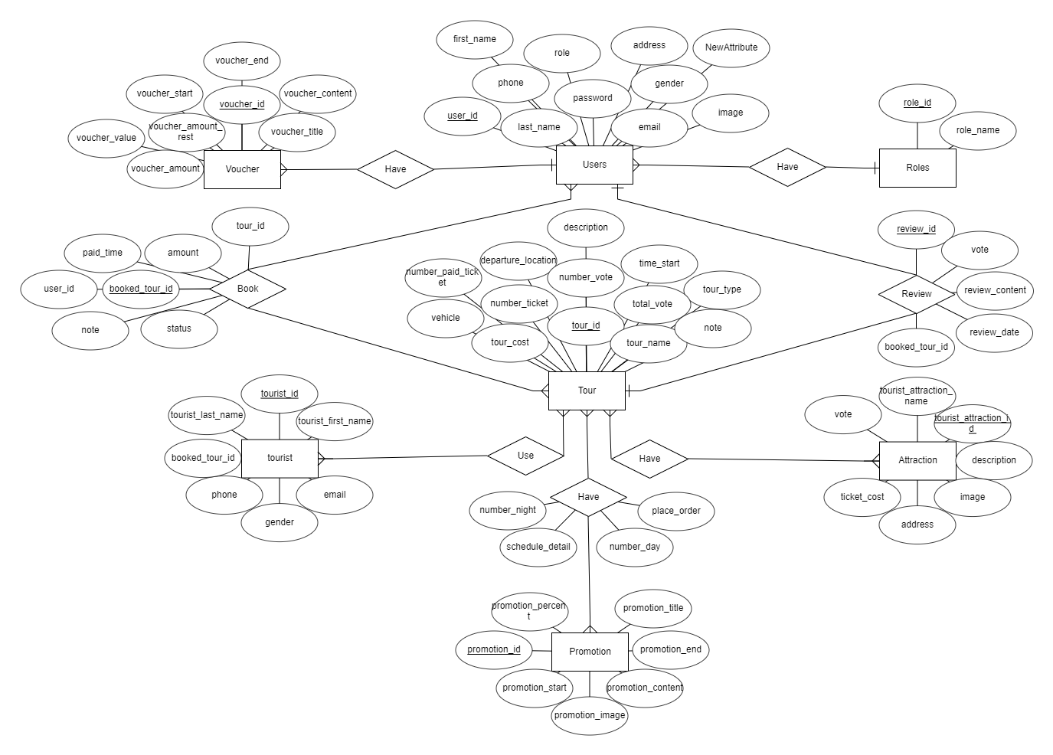**Entity Relationship Diagram**
  2. **Table Relationship Diagram**

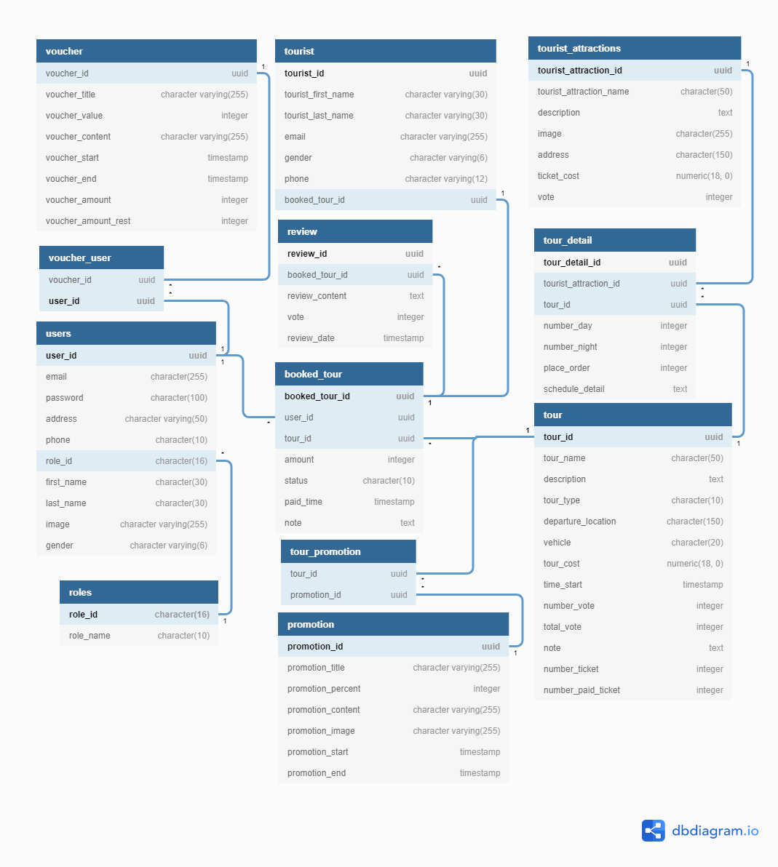

* 1. **Detail**
     1. **voucher**

|  |  |  |  |  |  |
| --- | --- | --- | --- | --- | --- |
| **Attributes** | **Datatype** | **Null** | **Key** | **Default** | **Extra** |
| voucher_id | uuid | Not | PK | uuid_generate_v4() |  |
| voucher_title | character varying(255) |  |  |  |  |
| voucher_value | integer |  |  |  |  |
| voucher_content | character varying(255) |  |  |  |  |
| voucher_start | timestamp |  |  |  |  |
| voucher_end | timestamp |  |  |  |  |
| voucher_amount | integer |  |  |  |  |
| voucher_amount_rest | integer |  |  |  |  |
|  |  |  |  |  |  |

* + 1. **voucher_user**

|  |  |  |  |  |  |
| --- | --- | --- | --- | --- | --- |
| **Attributes** | **Datatype** | **Null** | **Key** | **Default** | **Extra** |
| voucher_id | uuid | Not | FK, PK | uuid_generate_v4() |  |
| user_id | uuid | Not | FK, PK | uuid_generate_v4() |  |
|  |  |  |  |  |  |

* + 1. **users**

|  |  |  |  |  |  |
| --- | --- | --- | --- | --- | --- |
| **Attributes** | **Datatype** | **Null** | **Key** | **Default** | **Extra** |
| user_id | uuid | Not | PK, FK | uuid_generate_v4() |  |
| email | character(255) |  |  |  |  |
| Password | character(100) |  |  |  |  |
| address | character varying(50) |  |  |  |  |
| phone | character(10) |  |  |  |  |
| role_id | character(16) | Not | FK |  |  |
| first_name | character(30) |  |  |  |  |
| last_name | character(30) |  |  |  |  |
| image | character varying(255) |  |  |  |  |
| gender | character varying(6) |  |  |  |  |
|  |  |  |  |  |  |

* + 1. **roles**

|  |  |  |  |  |  |
| --- | --- | --- | --- | --- | --- |
| **Attributes** | **Datatype** | **Null** | **Key** | **Default** | **Extra** |
| role_id | character(16) | Not | PK |  |  |
| role_name | character(10) |  |  |  |  |
|  |  |  |  |  |  |

* + 1. **tourist**

|  |  |  |  |  |  |
| --- | --- | --- | --- | --- | --- |
| **Attributes** | **Datatype** | **Null** | **Key** | **Default** | **Extra** |
| tourist_id | uuid | Not | PK | uuid_generate_v4() |  |
| tourist_first_name | character varying(30) |  |  |  |  |
| tourist_last_name | character varying(30) |  |  |  |  |
| email | character varying(255) |  |  |  |  |
| gender | character varying(6) |  |  |  |  |
| phone | character varying(12) |  |  |  |  |
| booked_tour_id | uuid | Not | FK | uuid_generate_v4() |  |
|  |  |  |  |  |  |

* + 1. **booked_tour**

|  |  |  |  |  |  |
| --- | --- | --- | --- | --- | --- |
| **Attributes** | **Datatype** | **Null** | **Key** | **Default** | **Extra** |
| booked_tour_id | uuid | Not | PK | uuid_generate_v4() |  |
| user_id | uuid | Not | FK | uuid_generate_v4() |  |
| tour_id | uuid | Not | FK | uuid_generate_v4() |  |
| amount | integer |  |  |  |  |
| status | character(10) |  |  |  |  |
| paid_time | timestamp |  |  |  |  |
| note | text |  |  |  |  |
|  |  |  |  |  |  |

* + 1. **tour**

|  |  |  |  |  |  |
| --- | --- | --- | --- | --- | --- |
| **Attributes** | **Datatype** | **Null** | **Key** | **Default** | **Extra** |
| tour_id | uuid | Not | PK | uuid_generate_v4() |  |
| tour_name | character(50) |  |  |  |  |
| description | text |  |  |  |  |
| tour_type | character(10) |  |  |  |  |
| departure_location | character(150) |  |  |  |  |
| vehicle | character(20) |  |  |  |  |
| tour_cost | numeric(18, 0) |  |  |  |  |
| time_start | timestamp |  |  |  |  |
| number_vote | integer |  |  |  |  |
| total_vote | integer |  |  |  |  |
| note | text |  |  |  |  |
| number_ticket | integer |  |  |  |  |
| number_paid_ticket | integer |  |  |  |  |
|  |  |  |  |  |  |

* + 1. **tourist_attractions**

|  |  |  |  |  |  |
| --- | --- | --- | --- | --- | --- |
| **Attributes** | **Datatype** | **Null** | **Key** | **Default** | **Extra** |
| tourist_attraction_id | uuid | Not | PK | uuid_generate_v4() |  |
| tourist_attraction_name | character(50) |  |  |  |  |
| description | text |  |  |  |  |
| image | character(255) |  |  |  |  |
| address | character(150) |  |  |  |  |
| ticket_cost | numeric(18, 0) |  |  |  |  |
| vote | integer |  |  |  |  |
| discount | integer |  |  |  |  |
|  |  |  |  |  |  |

* + 1. **tour_detail**

|  |  |  |  |  |  |
| --- | --- | --- | --- | --- | --- |
| **Attributes** | **Datatype** | **Null** | **Key** | **Default** | **Extra** |
| tour_detail_id | uuid | Not | PK | uuid_generate_v4() |  |
| tour_id | uuid | Not | FK | uuid_generate_v4() |  |
| tourist_attraction_id | uuid | Not | FK | uuid_generate_v4() |  |
| number_day | integer |  |  |  |  |
| number_night | integer |  |  |  |  |
| place_order | integer |  |  |  |  |
| schedule_detail | text |  |  |  |  |
|  |  |  |  |  |  |

* + 1. **tour_promotion**

|  |  |  |  |  |  |
| --- | --- | --- | --- | --- | --- |
| **Attributes** | **Datatype** | **Null** | **Key** | **Default** | **Extra** |
| tour_id | uuid | Not | PK, FK | uuid_generate_v4() |  |
| promotion_id | uuid | Not | PK, FK | uuid_generate_v4() |  |
|  |  |  |  |  |  |

* + 1. **Promotion**

|  |  |  |  |  |  |
| --- | --- | --- | --- | --- | --- |
| **Attributes** | **Datatype** | **Null** | **Key** | **Default** | **Extra** |
| promotion_id | uuid | Not | PK | uuid_generate_v4() |  |
| promotion_title | character varying(255) |  |  |  |  |
| promotion_percent | integer |  |  |  |  |
| promotion_content | character varying(255) |  |  |  |  |
| promotion_image | character varying(255) |  |  |  |  |
| promotion_start | timestamp |  |  |  |  |
| promotion_end | timestamp |  |  |  |  |
|  |  |  |  |  |  |

* + 1. **Review**

|  |  |  |  |  |  |
| --- | --- | --- | --- | --- | --- |
| **Attributes** | **Datatype** | **Null** | **Key** | **Default** | **Extra** |
| review_id | uuid | Not | PK | uuid_generate_v4() |  |
| booked_tour_id | uuid | Not | FK | uuid_generate_v4() |  |
| review_content | text |  |  |  |  |
| vote | integer |  |  |  |  |
| review_date | timestamp |  |  |  |  |
|  |  |  |  |  |  |

1. **References**

[1] [ViboTourDB - dbdiagram.io](https://dbdiagram.io/d/5fd1ddc99a6c525a03ba89bb)

[2] [ERDPlus](https://erdplus.com/edit-diagram/1e13fdc0-131a-4ddc-9fd6-6884ddd344c1)